Bugs reported

**1**.

***Summary:***

Broken navigation link

***Steps to Reproduce:***

1. Main Page display – click on Popular Make: Lamborghini image
2. Click on ‘Buggy Rating’ link to go back to Main Page display

***Expected Result:***

Navigate back to the Main Page display

***Actual Result:***

Nothing happens, when you hover on the Buggy Rating link a url is displayed on the lower left corner -> https://buggy.justtestit.org/broken

***Screenshot:***

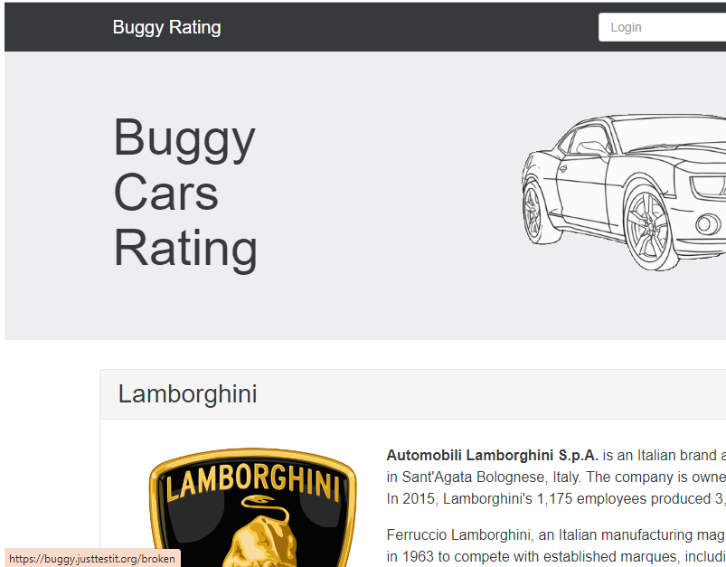

***Workaround:***

To go back use the Back button of the browser you are using.

**2.**

***Summary:***

Broken Image link

***Steps to Reproduce:***

1. Main Page – click Overall Rating Image link to navigate to Overall list page
2. Click filter : ‘Engine’
3. The list displays ‘Lancia Ypsilon’ as the first entry

***Expected Result:***

No broken link to any image

***Actual Result:***

The link to the image of the car ‘Lancia Ypsilon’ is broken

***Screenshot:***

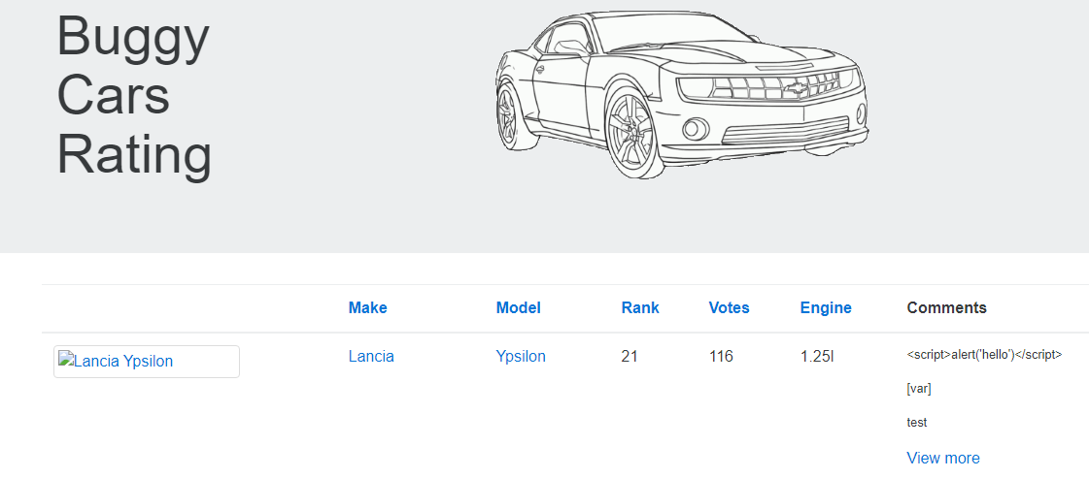

***Workaround:***

None

**3.**

***Summary:***

Filter does not arrange entries properly

***Steps to Reproduce:***

1. Main Page – click Overall Rating Image link to navigate to Overall list page
2. Click filter : ‘Rank’

***Expected Result:***

Rank should arrange entries from 1 to N entries

***Actual Result:***

Rank sort function is faulty. Rank goes from 1, 10, 11

***Screenshot:***

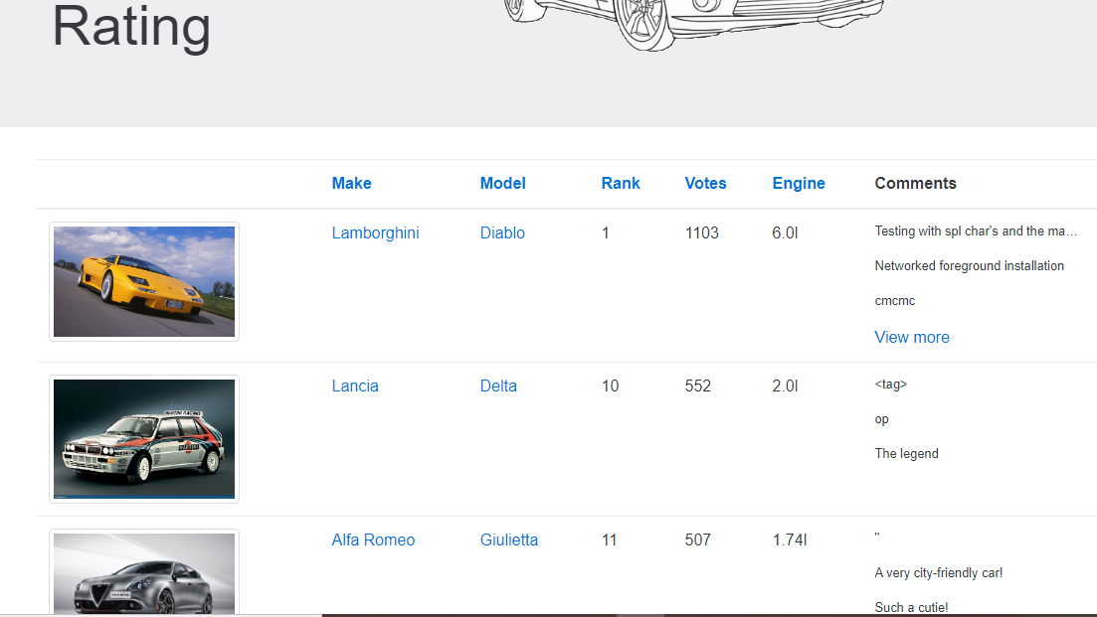

***Workaround:***

None